**1. pthread의 mutex만을 이용한 생산자/소비자**

#include <stdio.h>

#include <pthread.h>

int buffer[100];

int count = 0;

int in = -1, out = -1;

pthread_mutex_t mutex = PTHREAD_MUTEX_INITIALIZER;

void* producer(void *pData);

void* consumer(void *pData);

int main(void)

{

int i;

pthread_t threads[2];

pthread_create(&threads[0], NULL, producer, NULL);

pthread_create(&threads[1], NULL, consumer, NULL);

for (i=0; i<2; i++)

pthread_join(threads[i], NULL);

return 0;

}

void* producer(void *pData)

{

int i;

for (i=0; i<300; i++)

{

while(count == 100);

pthread_mutex_lock(&mutex);

in++;

in %= 100;

buffer[in] = i;

count++;

pthread_mutex_unlock(&mutex);

printf("Produce data = %d\n", buffer[in]);

}

}

void* consumer(void *pData)

{

int i,data;

for (i=0; i<300; i++)

{

while(count == 0);

pthread_mutex_lock(&mutex);

out++;

out %= 100;

data = buffer[out];

count--;

pthread_mutex_unlock(&mutex);

printf("Consume data = %d\n", data);

}

}

**실행결과:**

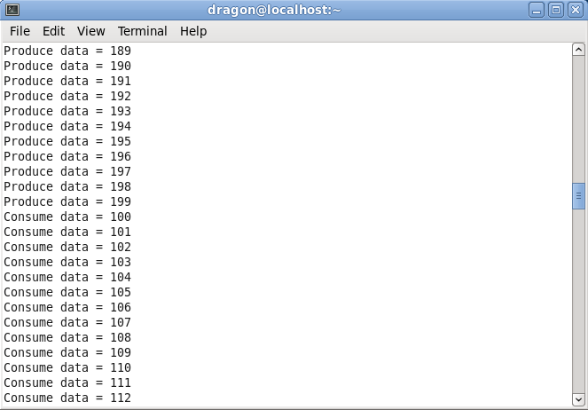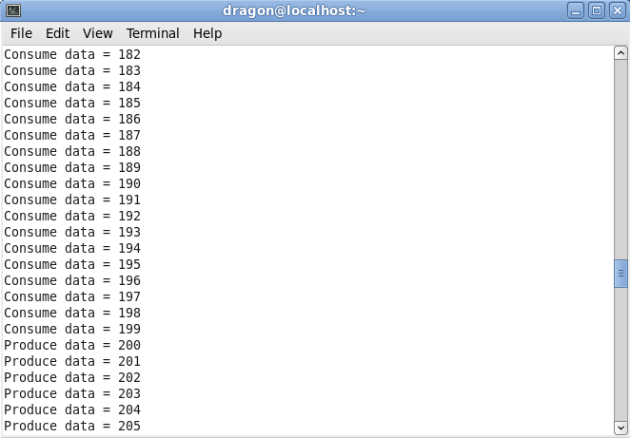

-Produce가 생산한 만큼 Consumer가 소비한다. Producer는 100개를 초과하여 생산하지 못한다.

**2. pthread의 mutex와 condition을 이용한 생산자/소비자**

#include <stdio.h>

#include <pthread.h>

int buffer[100];

int count = 0;

int in = -1, out = -1;

pthread_mutex_t mutex = PTHREAD_MUTEX_INITIALIZER;

pthread_cond_t buffer_has_space = PTHREAD_MUTEX_INITIALIZER;

pthread_cond_t buffer_has_data = PTHREAD_MUTEX_INITIALIZER;

void* producer(void *pData);

void* consumer(void *pData);

int main(void)

{

int i;

pthread_t threads[2];

pthread_create(&threads[0], NULL, producer, NULL);

pthread_create(&threads[1], NULL, consumer, NULL);

for (i=0; i<2; i++)

pthread_join(threads[i], NULL);

return 0;

}

void* producer(void *pData)

{

int i;

for (i=0; i<300; i++)

{

pthread_mutex_lock(&mutex);

if(count == 100)

pthread_cond_wait(&buffer_has_space, &mutex);

in++;

in %= 100;

buffer[in] = i;

count++;

pthread_cond_signal(&buffer_has_data);

pthread_mutex_unlock(&mutex);

printf("Produce data = %d\n", buffer[in]);

}

}

void* consumer(void *pData)

{

int i,data;

for (i=0; i<300; i++)

{

pthread_mutex_lock(&mutex);

if(count == 0)

pthread_cond_wait(&buffer_has_data, &mutex);

out++;

out %= 100;

data = buffer[out];

count--;

pthread_cond_signal(&buffer_has_space);

pthread_mutex_unlock(&mutex);

printf("Consume data = %d\n", data);

}

}

**실행결과:**

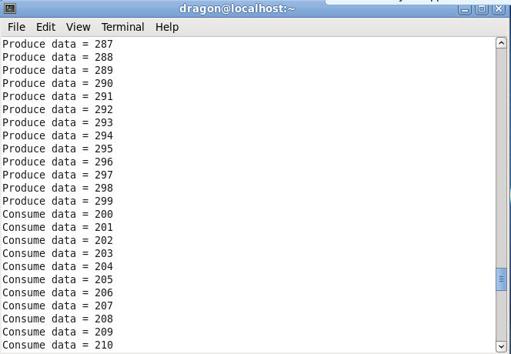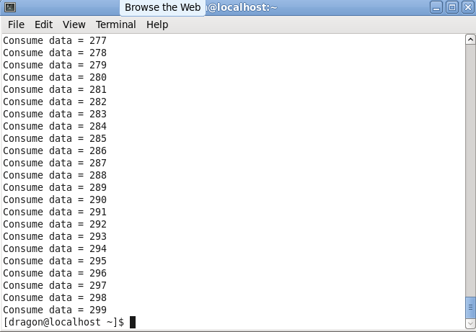

-Produce가 생산한 만큼 Consumer가 소비한다. Producer는 100개를 초과하여 생산하지 못한다.

**3. pthread의 mutex와 semaphore를 이용한 생산자/소비자**

#include <stdio.h>

#include <pthread.h>

#include <semaphore.h>

int buffer[100];

int count = 0;

int in = -1, out = -1;

pthread_mutex_t mutex = PTHREAD_MUTEX_INITIALIZER;

void* producer(void *pData);

void* consumer(void *pData);

sem_t full, empty;

int main(void)

{

int i;

sem_init(&empty,0,0);

sem_init(&full,0,100);

pthread_t threads[2];

pthread_create(&threads[0], NULL, producer, NULL);

pthread_create(&threads[1], NULL, consumer, NULL);

for (i=0; i<2; i++)

pthread_join(threads[i], NULL);

return 0;

}

void* producer(void *pData)

{

int i;

for (i=0; i<300; i++)

{

sem_wait(&full);

pthread_mutex_lock(&mutex);

in++;

in %= 100;

buffer[in] = i;

count++;

printf("Produce data = %d\n", buffer[in]);

pthread_mutex_unlock(&mutex);

sem_post(&empty);

}

}

void* consumer(void *pData)

{

int i,data;

for (i=0; i<300; i++)

{

sem_wait(&empty);

pthread_mutex_lock(&mutex);

out++;

out %= 100;

data = buffer[out];

count--;

printf("Consume data = %d\n", data);

pthread_mutex_unlock(&mutex);

sem_post(&full);

}

}

**실행결과 :**

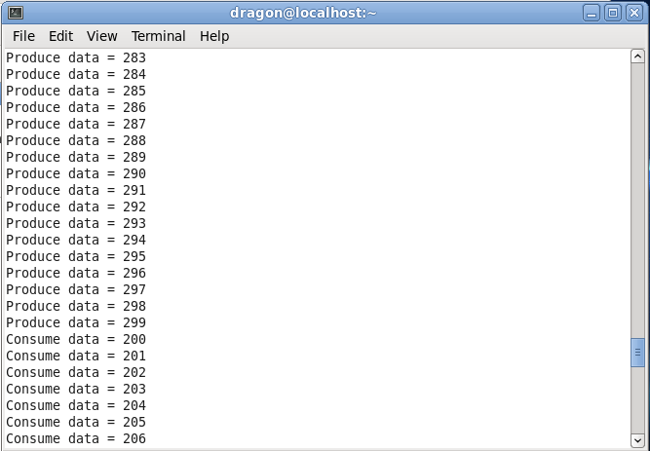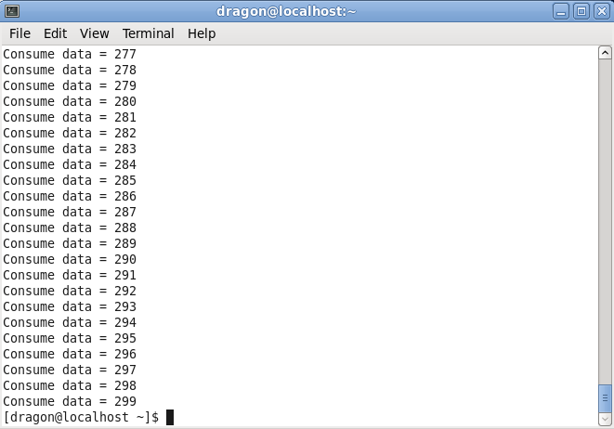

-Produce가 생산한 만큼 Consumer가 소비한다. Producer는 100개를 초과하여 생산하지 못한다.